Dear Sir / Madam,
I’m writing to share an update on Local Government Reorganisation across Lancashire.
Today marks an important step in the Government’s process, with the Ministry of Housing, Communities and Local Government announcing its preferred option for how local government will be organised in Lancashire.
Subject to Parliamentary approval, four new unitary authorities will be created across the county, to replace the current 15 councils.
This is the option the Government has chosen.
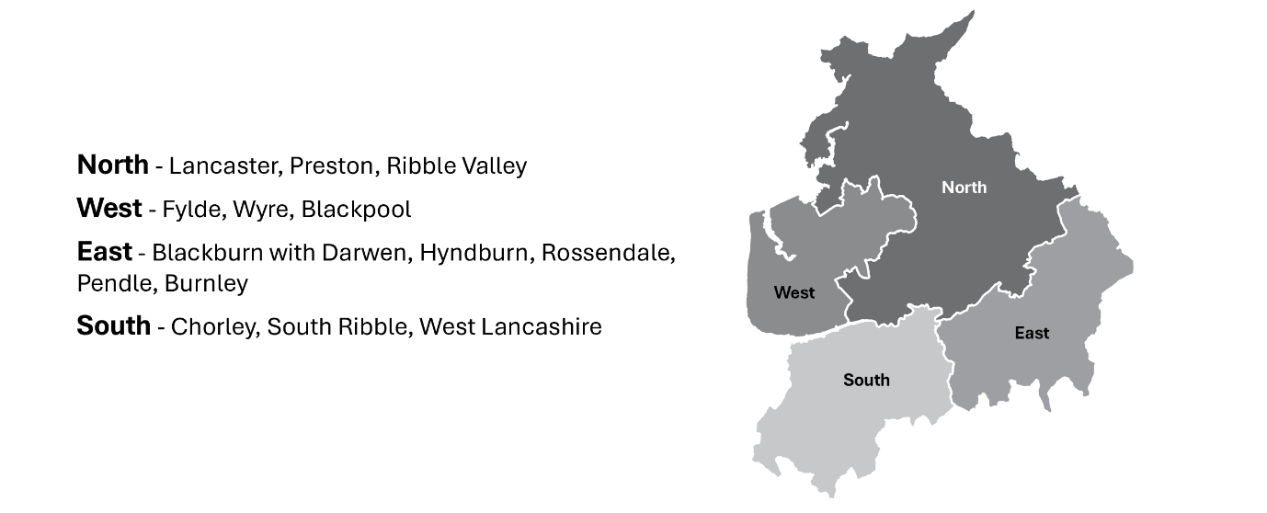
Councils across Lancashire will now continue to work together to plan the future structure of local government, including the transition to these new arrangements and the establishment of the new unitary councils.
We recognise the important role that town and parish councils play in supporting local communities and representing residents at a neighbourhood level. Your insight and local leadership will be vital as this process progresses.
Our focus remains on delivering strong, sustainable services and achieving the best possible outcomes for residents and communities across Lancashire.
There are no immediate changes to services, and it continues to be business as usual. Residents will continue to access services in the same way, and we remain fully focused on delivering day-to-day support.
We are committed to keeping town and parish councils informed and involved. There will be further opportunities to engage as more detail becomes available, and we will share updates as the programme progresses.
If you have any questions or would like to discuss this further, please do not hesitate to get in touch at LGR@lancashire.gov.uk.
Thank you for your continued support and the vital role you play within your community.
Kind regards,
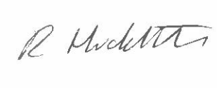
Rebecca Huddleston
Chief Executive

